CSC208 - Assignment part one Week Two #15 Dykes CSC 208

1. Solve quadratic equations
   1. 
   2. 

= 4/2 or -2/2 = 2 or - 1

1. Consider the equation of the line 2x + 3y = 6. Find the x- and y-intercepts of the line then sketch the line.

X intercept 2x + 3(0) = 6 = 2x= 3 x = 2/3

-3 -3

Y intercept 2(0) + 3y = 6 =3y = 6 y = 2

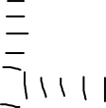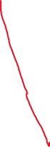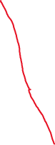

1. Given , evaluate f(-1) , f(0), f(2), f(a), f(a+b)
2. Given , evaluate the difference quotient
3. Find the limits
   1. 
   2. 
   3. 
   4. 

=

1. Find the derivative of  at point x= 3 using the limit formula. Interpret your answer
   1. Find the derivative by applying appropriate rules of derivative.

1. Do problem 6 with  at point x = -1.

1. Use rules of differentiation to find the derivative of the following functions
   1. ; find f’(1)
   2. ; find f’(2)